QMM Assignment DEA

Pavan Chaitanya

2022-10-26

# Upload libraries needed  
library(Benchmarking)

## Loading required package: lpSolveAPI

## Loading required package: ucminf

## Loading required package: quadprog

##   
## Loading Benchmarking version 0.30h, (Revision 244, 2022/05/05 16:31:31) ...

## Build 2022/05/05 16:31:40

library(tidyverse)

## ── Attaching packages  
## ───────────────────────────────────────  
## tidyverse 1.3.2 ──

## ✔ ggplot2 3.3.6 ✔ purrr 0.3.4   
## ✔ tibble 3.1.8 ✔ dplyr 1.0.10  
## ✔ tidyr 1.2.0 ✔ stringr 1.4.1   
## ✔ readr 2.1.2 ✔ forcats 0.5.2   
## ── Conflicts ────────────────────────────────────────── tidyverse_conflicts() ──  
## ✖ dplyr::filter() masks stats::filter()  
## ✖ dplyr::lag() masks stats::lag()

# Compute the Formulation

#Here, we are going to create a matrix and values.  
  
# To create the vectors with our values  
input <- matrix(c(150,400,320,520,350, 320, 0.2, 0.7, 1.2, 2.0, 1.2, 0.7),ncol = 2)  
output <- matrix(c(14000,14000,42000,28000,19000,14000,3500,21000,10500,42000,  
25000, 15000),ncol = 2)  
  
# Assign column names  
colnames(input) <- c("staff_hours_daily","supplies_daily")  
colnames(output) <- c("reimbursed_patient_daily", "privately_paid_patient-daily")  
  
# To see the values of Input  
input

## staff_hours_daily supplies_daily  
## [1,] 150 0.2  
## [2,] 400 0.7  
## [3,] 320 1.2  
## [4,] 520 2.0  
## [5,] 350 1.2  
## [6,] 320 0.7

# To see the values of Output  
output

## reimbursed_patient_daily privately_paid_patient-daily  
## [1,] 14000 3500  
## [2,] 14000 21000  
## [3,] 42000 10500  
## [4,] 28000 42000  
## [5,] 19000 25000  
## [6,] 14000 15000

#As we can see, the six nursing homes owned by Hope Valley Health Care Association are providing the same values as the performance data table here.  
  
#We will conduct a Data Envelopment Analysis (DEA) in the part that follows. The DEA is an analytical method that can assist businesses in identifying and allocating their resources to improve their efficiency and have better practices.

# 1. Formulate and perform DEA analysis under all DEA assumptions of FDH, CRS, VRS, IRS, DRS, and FRH.

# DEA Analysis using FDH

# Now, we are going to formulate and compute the DEA analysis using FDH.  
# The Free disposability hull (FDH) is the assumption of dispose unwanted inputs and outputs. “Free disposability means that we can always produce fewer outputs with more inputs.” (DEA Slides)  
  
# Provide the input and output  
analysis_fdh<- dea(input,output,RTS = "fdh")  
  
# Create a data frame with effciency values  
eff_fdh <- as.data.frame(analysis_fdh$eff)  
  
# To assign an appropiate name  
colnames(eff_fdh) <- c("efficiency_fdh")

# DEA Analysis using CRS

# Now, we are going to formulate and compute the DEA analysis using Constant Returns to Scale (CRS).  
# The CRS is part of the scaling assumption, and it allows us to see if there is any possible combination to scale up or down.  
  
# Provide the input and output  
analysis_crs <- dea(input,output,RTS = "crs")  
  
# To see the effciency values  
eff_crs <- as.data.frame(analysis_crs$eff)  
  
# To assign an appropiate name  
colnames(eff_crs) <- c("efficiency_crs")

# DEA Analysis using VRS

# Now, we are going to formulate and compute the DEA analysis using Variable Returns to Scale (VRS).  
# VRS is also part of the scaling assumption, and it helps to estimate the efficiency of the variables whether an increase or decrease is not proportional.  
  
# Provide the input and output  
analysis_vrs <- dea(input,output,RTS = "vrs")  
  
# To see the effciency values  
eff_vrs <- as.data.frame(analysis_vrs$eff)  
  
# To assign an appropiate name  
colnames(eff_vrs) <- c("efficiency_vrs")

# DEA Analysis using IRS

# Now, we are going to formulate and compute the DEA analysis using Increasing Returns to Scale (IRS).  
# IRS indicates if it is possible to increate the operation scale.  
  
# Provide the input and output  
analysis_irs <- dea(input,output,RTS = "irs")  
  
# To see the effciency values  
eff_irs <- as.data.frame(analysis_irs$eff)  
  
# To assign an appropiate name  
colnames(eff_irs) <- c("efficiency_irs")

# DEA Analysis using DRS

# Now, we are going to formulate and compute the DEA analysis using Decreasing Returns to Scale (DRS).  
# DRS is the opposite of IRS, which its goal is to decrease the operation scale on any possible production process.  
  
# Provide the input and output  
analysis_drs <- dea(input,output,RTS = "drs")  
  
# To see the effciency values  
eff_drs <- as.data.frame(analysis_drs$eff)  
  
# To assign an appropiate name  
colnames(eff_drs) <- c("efficiency_drs")

# DEA Analysis using FRH

# Now, we are going to formulate and compute the DEA analysis using Free Replicability Hull (FRH).  
# FRH as well as FDH use mixed integer programming, which refers that the variables must be integers to find the optimal solution. The goal of FRH is to replace deterministic data using random variables.  
  
# Provide the input and output  
analysis_frh <- dea(input,output,RTS = "add")  
  
# To see the effciency values  
eff_frh <- as.data.frame(analysis_frh$eff)  
  
# To assign an appropiate name  
colnames(eff_frh) <- c("efficiency_frh")

# 2. Determine the Peers and Lambdas under each of the above assumptions

# Peers and Lambdas for FDH

# Identify the peers  
peer_fdh <- peers(analysis_fdh)  
  
# To assign an appropiate name  
colnames(peer_fdh) <- c("peer1_fdh")  
  
# Identify the relative weights given to the peers using lambda function  
lambda_fdh <- lambda(analysis_fdh)  
  
# To assign an appropiate column name for Lambda  
colnames(lambda_fdh) <- c("L1_fdh", "L2_fdh", "L3_fdh", "L4_fdh", "L5_fdh", "L6_fdh")

# Peers and Lambdas for CRS

# Identify the peers  
peer_crs <- peers(analysis_crs)  
  
# To assign an appropiate name  
colnames(peer_crs) <- c("peer1_crs", "peer2_crs", "peer3_crs")  
  
# Identify the relative weights given to the peers using lambda function  
lambda_crs <- lambda(analysis_crs)  
  
# To assign an appropiate column name for Lambda  
colnames(lambda_crs) <- c("L1_crs", "L2_crs", "L3_crs", "L4_crs")

# Peers and Lambdas for VRS

# Identify the peers  
peer_vrs <- peers(analysis_vrs)  
  
# To assign an appropiate name  
colnames(peer_vrs) <- c("peer1_vrs", "peer2_vrs", "peer3_vrs")  
  
# Identify the relative weights given to the peers using lambda function  
lambda_vrs <- lambda(analysis_vrs)  
  
# To assign an appropiate column name for Lambda  
colnames(lambda_vrs) <- c("L1_vrs", "L2_vrs", "L3_vrs", "L4_vrs", "L5_vrs")

# Peers and Lambdas for IRS

# Identify the peers  
peer_irs <- peers(analysis_irs)  
  
# To assign an appropiate name  
colnames(peer_irs) <- c("peer1_irs", "peer2_irs", "peer3_irs")  
  
# Identify the relative weights given to the peers using lambda function  
lambda_irs <- lambda(analysis_irs)  
  
# To assign an appropiate column name for Lambda  
colnames(lambda_irs) <- c("L1_irs", "L2_irs", "L3_irs", "L4_irs", "L5_irs")

# Peers and Lambdas for DRS

# Identify the peers  
peer_drs <- peers(analysis_drs)  
  
# To assign an appropiate name  
colnames(peer_drs) <- c("peer1_drs", "peer2_drs", "peer3_drs")  
  
# Identify the relative weights given to the peers using lambda function  
lambda_drs <- lambda(analysis_drs)  
  
# To assign an appropiate column name for Lambda  
colnames(lambda_drs) <- c("L1_drs", "L2_drs", "L3_drs", "L4_drs")

# Peers and Lambdas for FRH

# Identify the peers  
peer_frh <- peers(analysis_frh)  
  
# To assign an appropiate name  
colnames(peer_frh) <- c("peer1_frh")  
  
# Identify the relative weights given to the peers using lambda function  
lambda_frh <- lambda(analysis_frh)  
  
# To assign an appropiate column name for Lambda  
colnames(lambda_frh) <- c("L1_frh", "L2_frh", "L3_frh", "L4_frh", "L5_frh", "L6_frh")

# 3. Summarize your results in a tabular format

# FDH Results in Tabular form

# Create a tabular data with peer, lambda, and efficiency  
peer_lamb_eff_fdh <- cbind(peer_fdh, lambda_fdh, eff_fdh)  
  
# Show the summary chart  
peer_lamb_eff_fdh

## peer1_fdh L1_fdh L2_fdh L3_fdh L4_fdh L5_fdh L6_fdh efficiency_fdh  
## 1 1 1 0 0 0 0 0 1  
## 2 2 0 1 0 0 0 0 1  
## 3 3 0 0 1 0 0 0 1  
## 4 4 0 0 0 1 0 0 1  
## 5 5 0 0 0 0 1 0 1  
## 6 6 0 0 0 0 0 1 1

# The summary chart shown above, confirms that every DMU or facility is working using all its capacity and efficiency. Every peer was assigned one unit, for that reason, the Lambda values are 1, and efficiency are 1 as well.

# CRS Results in Tabular form

# Create a tabular data with peer, lambda, and efficiency  
peer_lamb_eff_crs <- cbind(peer_crs, lambda_crs, eff_crs)  
  
# Show the summary chart  
peer_lamb_eff_crs

## peer1_crs peer2_crs peer3_crs L1_crs L2_crs L3_crs L4_crs  
## 1 1 NA NA 1.0000000 0.00000000 0 0.0000000  
## 2 2 NA NA 0.0000000 1.00000000 0 0.0000000  
## 3 3 NA NA 0.0000000 0.00000000 1 0.0000000  
## 4 4 NA NA 0.0000000 0.00000000 0 1.0000000  
## 5 1 2 4 0.2000000 0.08048142 0 0.5383307  
## 6 1 2 4 0.3428571 0.39499264 0 0.1310751  
## efficiency_crs  
## 1 1.0000000  
## 2 1.0000000  
## 3 1.0000000  
## 4 1.0000000  
## 5 0.9774987  
## 6 0.8674521

# Regarding Constant Returns to Scale (CRS), the facilities 1, 2, 3, and 4 are using all its efficiency as the lambdas and peers prove. Facility 5 and 6, on the other hand, need parts of 1, 2, and 4 as the peers and lambdas show above. It means these two facilities (5 and 6) have room to improve because they are getting an efficiency of 97.74% and 86.74% respectively.

# VRS Results in Tabular form

# Create a tabular data with peer, lambda, and efficiency  
peer_lamb_eff_vrs <- cbind(peer_vrs, lambda_vrs, eff_vrs)  
  
# Show the summary chart  
peer_lamb_eff_vrs

## peer1_vrs peer2_vrs peer3_vrs L1_vrs L2_vrs L3_vrs L4_vrs L5_vrs  
## 1 1 NA NA 1.0000000 0.0000000 0 0 0.0000000  
## 2 2 NA NA 0.0000000 1.0000000 0 0 0.0000000  
## 3 3 NA NA 0.0000000 0.0000000 1 0 0.0000000  
## 4 4 NA NA 0.0000000 0.0000000 0 1 0.0000000  
## 5 5 NA NA 0.0000000 0.0000000 0 0 1.0000000  
## 6 1 2 5 0.4014399 0.3422606 0 0 0.2562995  
## efficiency_vrs  
## 1 1.0000000  
## 2 1.0000000  
## 3 1.0000000  
## 4 1.0000000  
## 5 1.0000000  
## 6 0.8963283

# Now we run the Variable Returns to Scale (VRS), we can identify that facility 1, 2, 3, 4, and 5 are working in all its capacity or efficiency. However, that does not happen with facility 6, which has an efficiency of 89.63%. As peers and lambdas show, facility 6 needs part of facility 1, 2, and 5 to achieve better efficiency.

# IRS Results in Tabular form

# Create a tabular data with peer, lambda, and efficiency  
peer_lamb_eff_irs <- cbind(peer_irs, lambda_irs, eff_irs)  
  
# Show the summary chart  
peer_lamb_eff_irs

## peer1_irs peer2_irs peer3_irs L1_irs L2_irs L3_irs L4_irs L5_irs  
## 1 1 NA NA 1.0000000 0.0000000 0 0 0.0000000  
## 2 2 NA NA 0.0000000 1.0000000 0 0 0.0000000  
## 3 3 NA NA 0.0000000 0.0000000 1 0 0.0000000  
## 4 4 NA NA 0.0000000 0.0000000 0 1 0.0000000  
## 5 5 NA NA 0.0000000 0.0000000 0 0 1.0000000  
## 6 1 2 5 0.4014399 0.3422606 0 0 0.2562995  
## efficiency_irs  
## 1 1.0000000  
## 2 1.0000000  
## 3 1.0000000  
## 4 1.0000000  
## 5 1.0000000  
## 6 0.8963283

# Increasing Returns to Scale (IRS) behives the same as Variable Returns to Scale (VRS) by getting facility 1, 2, 3, 4, and 5 are working all its efficiency, but facility 6 needs to improve needs from units 1, 2, and 5 to improve its efficiency which is 89.63%.

# DRS Results in Tabular form

# Create a tabular data with peer, lambda, and efficiency  
peer_lamb_eff_drs <- cbind(peer_drs, lambda_drs, eff_drs)  
  
# Show the summary chart  
peer_lamb_eff_drs

## peer1_drs peer2_drs peer3_drs L1_drs L2_drs L3_drs L4_drs  
## 1 1 NA NA 1.0000000 0.00000000 0 0.0000000  
## 2 2 NA NA 0.0000000 1.00000000 0 0.0000000  
## 3 3 NA NA 0.0000000 0.00000000 1 0.0000000  
## 4 4 NA NA 0.0000000 0.00000000 0 1.0000000  
## 5 1 2 4 0.2000000 0.08048142 0 0.5383307  
## 6 1 2 4 0.3428571 0.39499264 0 0.1310751  
## efficiency_drs  
## 1 1.0000000  
## 2 1.0000000  
## 3 1.0000000  
## 4 1.0000000  
## 5 0.9774987  
## 6 0.8674521

# Decreasing Returns to Scale (DRS) has a good efficiency in facility 1, 2, 3, and 4. Regarding facility 5 and 6, there is room they can improve. Both of them need part of facilities 1, 2, and 4 to be able to achieve their highest efficiency of 1 as we can prove in the previous table.

# FRH Results in Tabular form

# Create a tabular data with peer, lambda, and efficiency  
peer_lamb_eff_frh <- cbind(peer_frh, lambda_frh, eff_frh)  
  
# Show the summary chart  
peer_lamb_eff_frh

## peer1_frh L1_frh L2_frh L3_frh L4_frh L5_frh L6_frh efficiency_frh  
## 1 1 1 0 0 0 0 0 1  
## 2 2 0 1 0 0 0 0 1  
## 3 3 0 0 1 0 0 0 1  
## 4 4 0 0 0 1 0 0 1  
## 5 5 0 0 0 0 1 0 1  
## 6 6 0 0 0 0 0 1 1

# Free Replicability Hull (FRH) has a great efficiency in all its DMU. It behives the same as Free disposability hull (FDH), which all its values have their own peer, lambas and efficiency of 1.

# 4. Compare and contrast the above results

# Graphs for all FDH,CRS,VRS,IRS,DRS,FRH.

dea.plot(input,output,RTS="fdh",ORIENTATION="in-out",txt=TRUE, xlab ="Input", ylab= "Output", main="Free disposability hull (FDH) Graph")

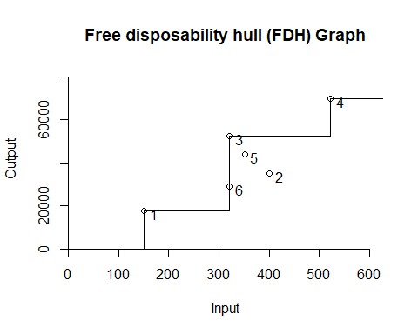

dea.plot(input,output,RTS="vrs",ORIENTATION="in-out",  
txt=TRUE, xlab = "Input", ylab= "Output", main="Variable Returns to Scale (VRS) Graph")

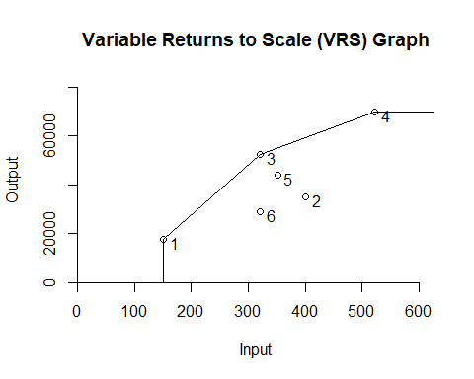

dea.plot(input,output,RTS="drs",ORIENTATION="in-out",  
txt=TRUE, xlab = "Input", ylab= "Output", main="Decreasing Returns to Scale (DRS) Graph")

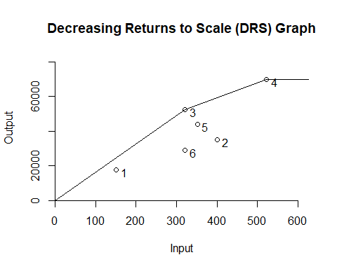

dea.plot(input,output,RTS="irs",ORIENTATION="in-out",  
txt=TRUE, xlab = "Input", ylab= "Output", main="Increasing Returns to Scale (IRS) Graph")

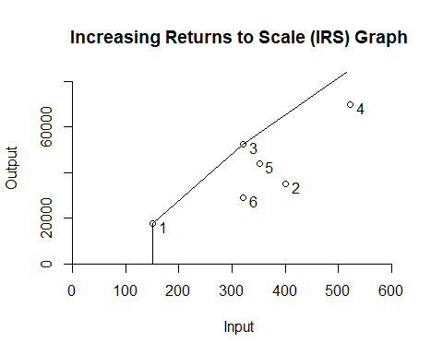

dea.plot(input,output,RTS="crs",ORIENTATION="in-out",  
txt=TRUE,xlab = "Input", ylab= "Output", main="Constant Returns to Scale (CRS) Graph")

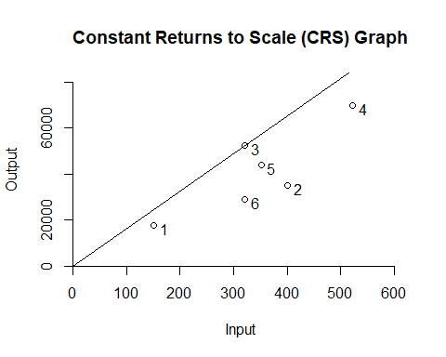

dea.plot(input,output,RTS="add",ORIENTATION="in-out",  
txt=TRUE, xlab = "Input", ylab= "Output", main="Free Replicability Hull (FRH) Graph")

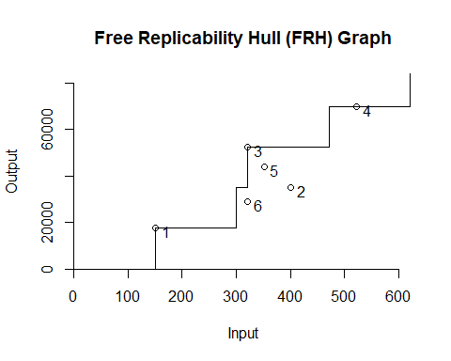

#We may compare the outcomes of each DEA model using these charts.  
  
# The principle of estimating the technology via a minimal extrapolation strategy is one that all DEA models share, as we learnt in this session (DEA Slides).  
  
# FDH is the smallest technology set, as can be shown. It aims to generate more inputs from fewer outputs (the number of patient days funded privately and the number of patient days reimbursed by third parties) (staffing labor and the cost of supplies). FDH is typically the model that businesses want the most, however because of its assumptions, it has several limitations. All of the efficiencies in this model are 1, as we can demonstrate, but when compared to other models, it is not as efficient as we believe it to be since we identify areas/units for improvement.  
  
# Because VRS "fills-out" the gaps that FDH eliminated, it is larger than FDH. We can observe that unit 6 can increase its effectiveness in this area.  
  
# The charts show that DRS and IRS are bigger than VRS. While the IRS seeks to boost technology for high input values, DRS tries to increase the set for lower input values. DRS suggests that units 5 and 6 might become more efficient, while IRS suggests that facility 6 might as well.  
  
# The largest technology set is CRS, which enables us to determine whether any combinations could be used to scale up or down. The efficiency results indicate that units 5 and 6 require improvement.  
  
# FRH aims to replace deterministic data with random variables, and is larger than FDH but less than CRS based on the arrow network mentioned in class.